Assignment #___2__ Name __Tarun Banda_______

Program 1: Names.java

**Screenshot (Sample Run) :**  GIVE IMAGE screen shot of the program running

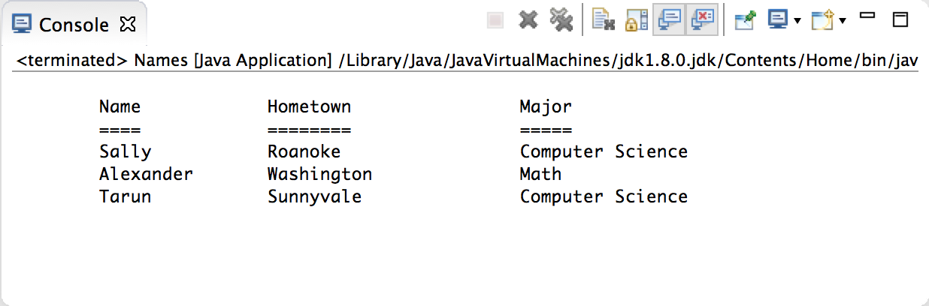

Program 2: Birds.java

**Screenshot (Sample Run):** GIVE IMAGE screen shot of the program running

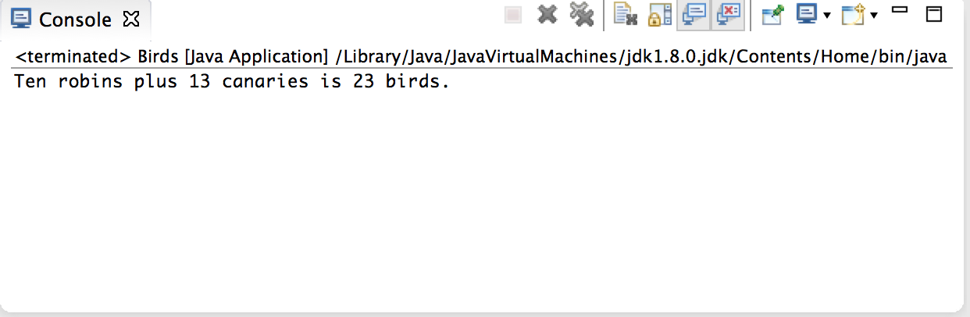

Program 3: FutureInvestments.java

**Screenshot (Sample Run):** GIVE IMAGE screen shot of the program running

